TRC3500 Use of AI Disclosure Form
In TRC3500, you may use any AI tools at your disposal, in any capacity, to complete the assigned work. However, you must disclose which tools you used and how. Generative AI produces feedback or content that may be incorrect or inappropriate. You are fully responsible for the state of work that you submit.

Instructions
- An AI disclosure form must be submitted for the group with every report. Appendix and example need not be included.
- Address every task category listed in the form
- Add tasks if you feel you did something that doesn’t fit in any category but warrants disclosure
- All uses (“Y”) must indicate what tool you used and for what purpose
- See explanations of the categories in the appendix

Task | N | Y | If Y, specify tool and scope
Coding: algorithms | X
Coding: syntax assistance | X |  | GPT-4o was used to write some of the Python code used in digital signal processing, MSE calculation, and JND calculation
Coding: debugging |  | Y | GPT-4o was used to debug the C code used in STM IDE
Coding: refactoring | X
Coding: documentation | X
Writing | X
Reviewing text |  | Y | GPT-4o was used to polish some paragraphs to better reflect an academic writing style, though the content was all initially human-written. The suggested content was further edited, but some phrases were taken directly.
Brainstorming | X
Image generation | X


TRC3500
Project 3: Breath Rate Estimation
Group B1

Group members:
Leticia Ann Lariche (33203113)
Belle Pang Hsuan Yu (33603871)
Mah Chun Hoong (33334749)
Chan Jia Wen (33381267)
Teoh Xhu Wei (32694903)

Table of Contents
1.0 Introduction 4
2.0 Electrical Circuit Design 4
3.0 Digital Signal Processing and Data Fusion 7
4.0 Performance Assessment 9
5.0 Conclusion 11
6.0 References 11
7.0 Appendix 11

1.0 Introduction
This report outlines the design and signal processing of a robust breath-rate sensing module to be integrated into wearable biosensing technology systems. The module comprises a thermistor, a conductive rubber cord stretch sensor, and an STM32 microcontroller to provide real-time sensor data as serial ADC outputs, as well as op-amps to amplify the desired signals. The system is able to reliably count the number of breathing cycles completed while the user is wearing it through a digital processing system that reduces noise and detects the inhales and exhales of the user through gradient changes.

2.0 Electrical Circuit Design
Two sensing elements were selected for the prototype: the TMP61 temperature sensor and a conductive-rubber strain sensor. Both devices were interfaced to a simple 5V voltage-divider network to obtain their raw output range. The results are summarised in Table 1.

Table 1. The values found in the initial hardware testing
 | TMP61 | Conductive Rubber
Resistance at full Inhalation (kΩ) | 9.2 | 1.8
Resistance at full exhale (kΩ) | 6.8 | 1.5
Resistance range (kΩ) | 2.4 | 0.3
Voltage at full Inhalation (mV) | 421 | 3214
Voltage at full exhale (mV) | 318 | 3000
Voltage Range (mV) | 103 | 214

From this preliminary data, it was observed that the two sensors exhibit inverse resistance–stimulus relationships. Although this inversion is not inherently problematic, it offers a convenient consistency check during system validation to ensure the signals are aligned in time and being multiplexed correctly.

The voltage change between a full inhale and exhale is a few hundred millivolts for each sensor, even when recorded under conditions of full lung expansion and firm sensor contact. Realistic breathing will be less pronounced, so in order to make this system fit for a wearable solution, the output must be amplified through the use of op-amps and carefully chosen gains. The conductive rubber values can exceed the STM32’s ADC maximum detectable range of 3.3V, so the output needs to be shifted downward to avoid the data being cut off.

The schematic diagrams for both sensor circuits are presented in Figures 1 and 2. These figures illustrate the voltage divider and TLV9054 op-amp configurations used to interface the sensors. A gain of 10 was applied for the conductive rubber sensor, expanding the voltage range from approximately 200 mV to 2 V. For the TMP61, a gain of 30 was employed, increasing the output range from 103 mV to approximately 3V. Since the STM32 microcontroller can only read input voltages within a 0-3.3 V range, a DC bias was introduced to shift the amplified signals into this acceptable range and to allow detection of both increases and decreases in sensor output without signal clipping.

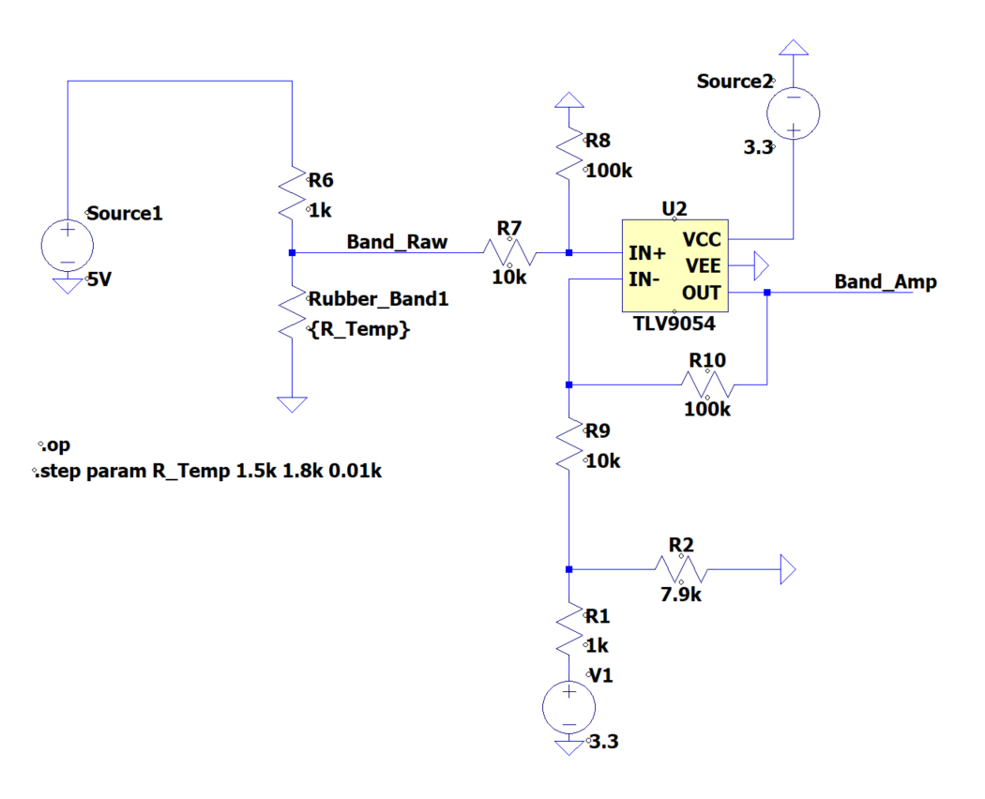
Fig 1. Schematic diagram of the conductive rubber circuit
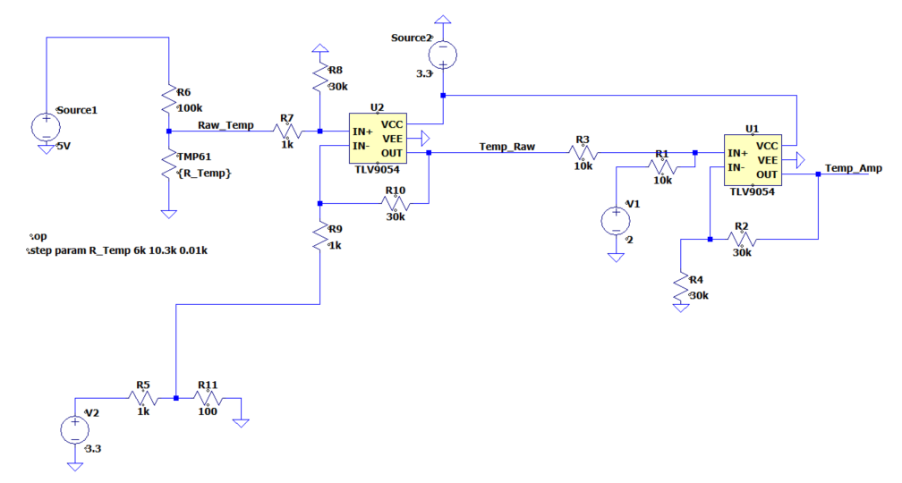
Fig 2. Schematic diagram of the TMP61 circuit

The reference voltages of the differential amplifiers were then adjusted: 3.0V for the conductive rubber circuit and 0.3V for the TMP61 circuit. However, in the TMP61 circuit, the output voltage after amplification and biasing occasionally exceeded 3.3 V. To correct for this and prevent saturation, an additional subtraction stage was introduced to reduce the final output by 2 V, ensuring compatibility with the ADC input range of the STM32.

Figures 3a and 3b present the simulated output of the circuit, using resistor values incremented by 0.01 Ω to emulate the varying resistance of the sensors. The range of simulated resistances corresponds to values obtained during the initial data collection phase. The simulation results demonstrate successful amplification of the differential signal while maintaining the output within the ADC-readable range of 0 to 3.3 V. It is worth noting that noise reduction was not a hardware consideration, as the data will have digital filtering performed on it.

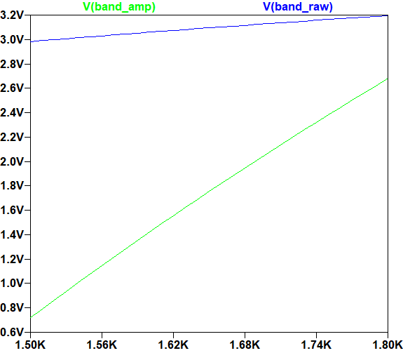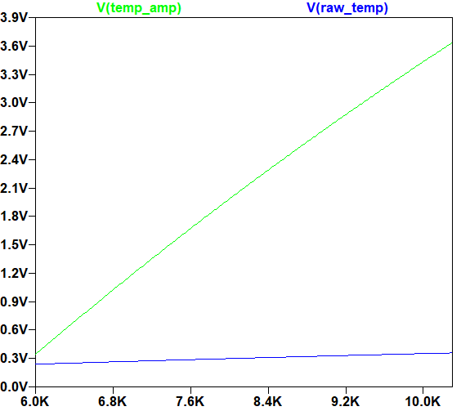
Fig 3a and 3b. Original outputs (green) compared to amplified output (blue). The rubber circuit is on the left, and the TMP61 is on the right

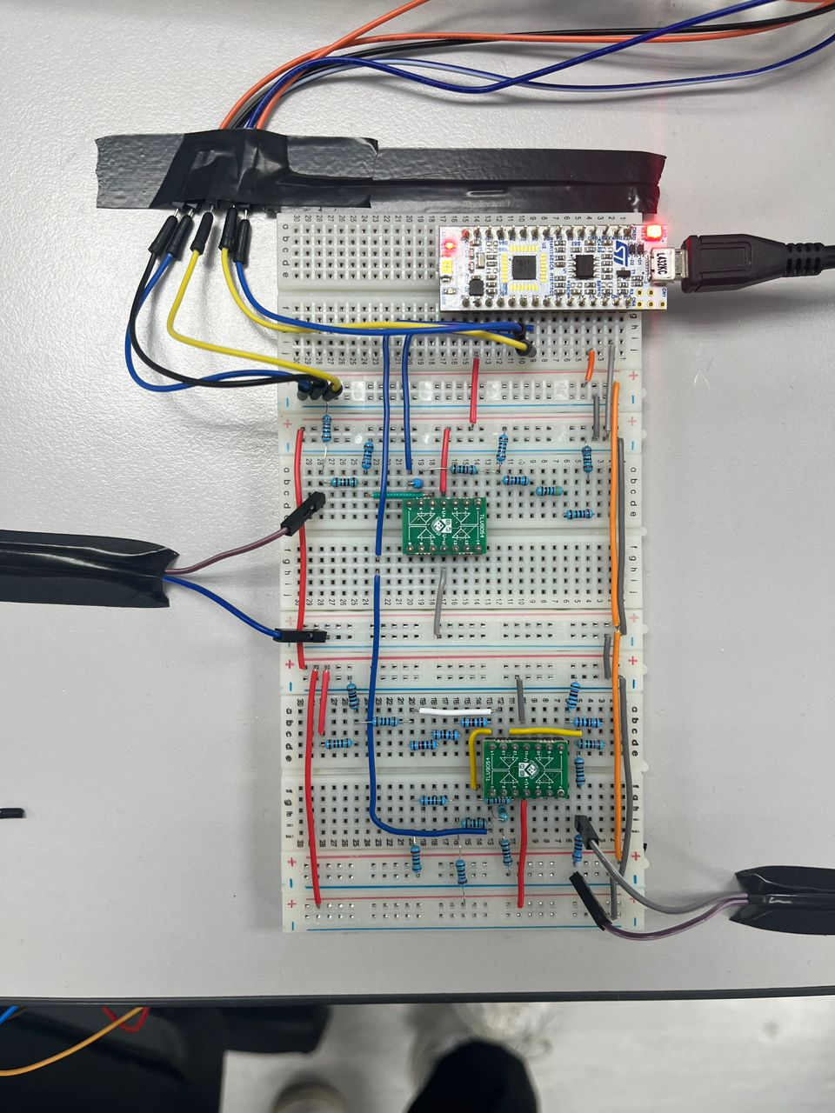
Fig 4. Top view of the breath rate estimation system

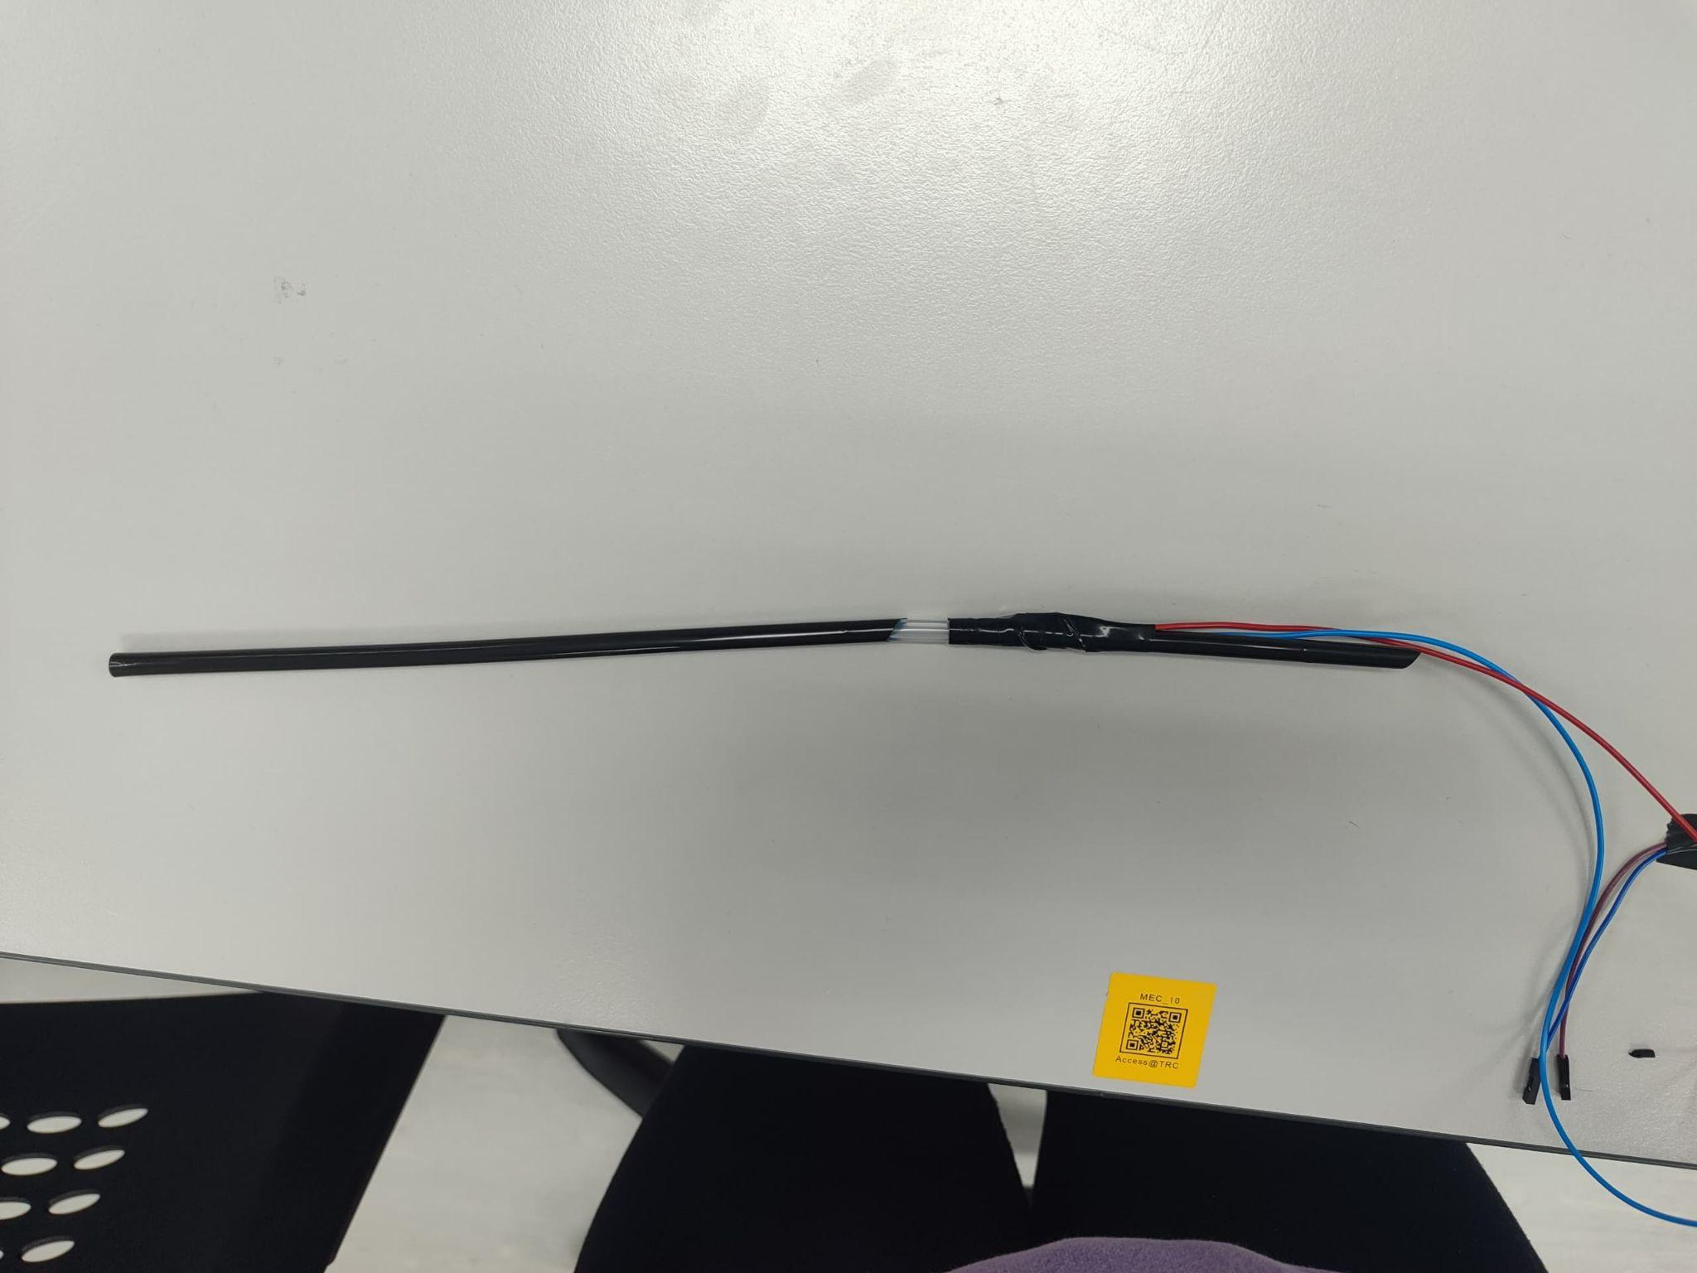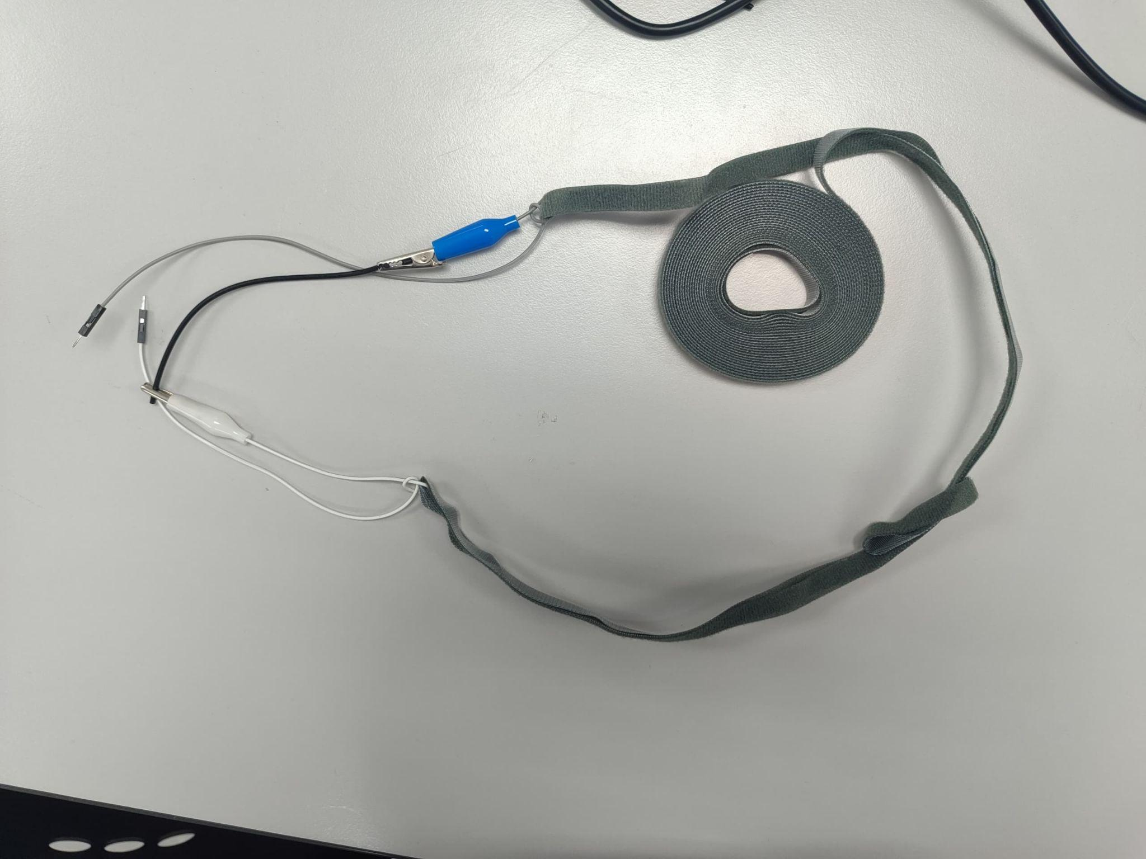
Fig 5a and 5b. The apparatus used with the circuit. Fig 5a. shows the tube with TMP61 and straw attached, and Fig 5b. shows the conductive rubber to be wrapped around the user’s chest.

Following successful simulation results, the physical circuit was constructed, as shown in Figures 4, 5a and 5b. Given that the intended application is a wearable device, several practical design considerations were incorporated to ensure usability, comfort, and hygiene. Firstly, the TMP61 was embedded within a straw and sealed to enable consistent airflow over the sensor during use. To maintain hygiene and facilitate reuse, a flexible tube adapter was added to one end of the straw, allowing for easy straw replacement.

Secondly, the conductive rubber sensor was attached to a chest strap using crocodile clips and secured to a Velcro band. To accommodate users of varying body sizes, the Velcro strap was designed to be initially loose and can be folded to achieve the desired fit without overstretching the rubber.

3.0 Digital Signal Processing and Data Fusion
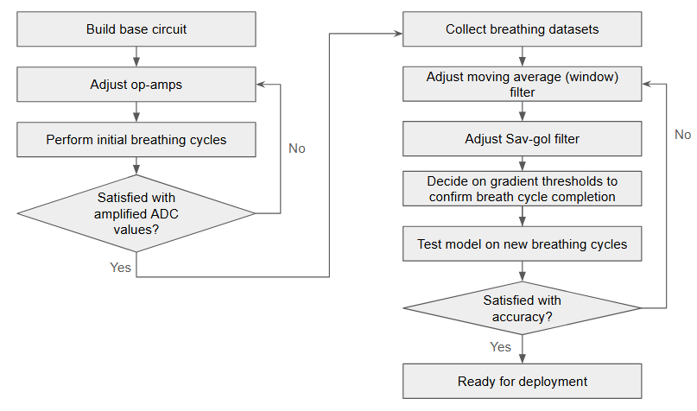
Fig 6. Detection system calibration and testing flow chart

Digital signal processing (DSP) is key to processing raw data from sensors. As the sensors provided for this project are simple, they are not capable of locally processing their data before sending it to a central hub for analysis. Due to this, central data fusion was chosen—the sensors’ data is sent through raw ADC values from the STM32 to the laptop interface, where the data can then be processed through a Python program. Using a Python program allows easy visualisation and analysis of the data. Using digital multiplexing in the STM32 C code, the system collects samples at a 100Hz rate for up to 60 seconds, resulting in a maximum of 12,000 samples across the two sensors used.

As the amplification stage increased both the sensor signal and the accompanying noise, a Finite Impulse Response (FIR) filter—specifically, a moving average window of 20 data points—was implemented to smooth the signal while preserving key features. An Infinite Impulse Response (IIR) filter was considered but ultimately deemed unsuitable due to the short duration of recording, which limited the need for drift correction. Additionally, IIR filters tend to be less stable and more challenging to tune.

It was found that the noise in the system was uncorrelated noise, which could be cancelled out with FIR rather than more complicated techniques such as wavelet smoothing, because the signal is periodic rather than defined by transient bursts.

To further enhance signal clarity, a low-pass Savitzky-Golay filter was applied during post-processing. Additionally, a 10% bias was introduced to the TMP61 data to accentuate peaks and troughs for improved interpretability. A comparison between the raw and processed signals is shown in Figure 7.
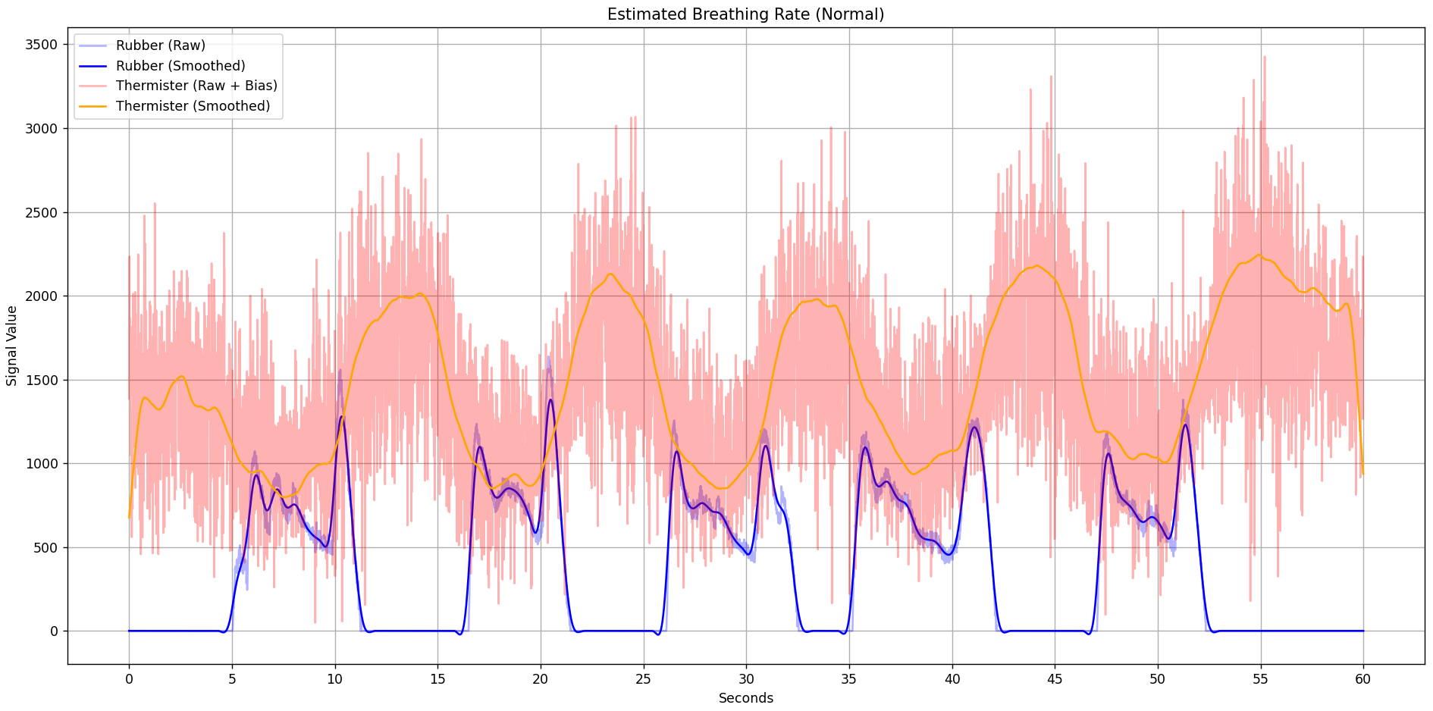
Fig 7. The raw and processed data for five cycles of normal breathing

Figures 8 and 9 illustrate that a conductive rubber sensor exhibits a voltage trough during exhalation, corresponding to chest contraction, while the TMP61 shows a temperature peak due to the warm exhaled air passing over it. Though the signals are shifted slightly from the ground truth due to minor delays in the prints of the STM interface to the terminal, the general shape of the waves can be seen.

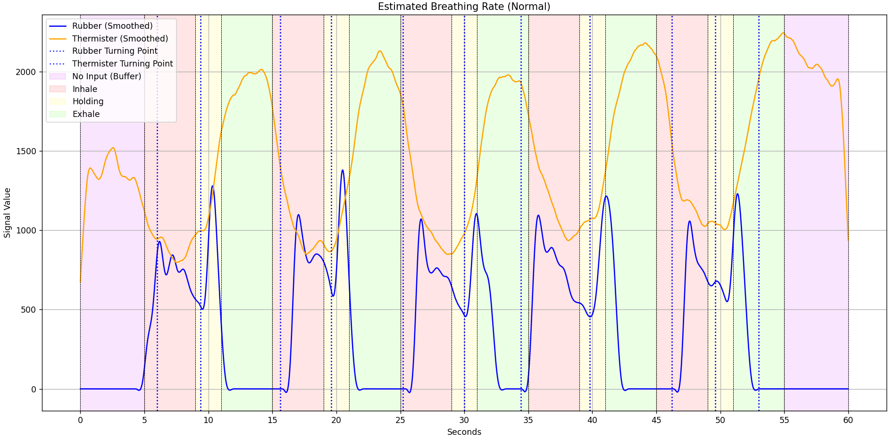
Fig 8. Normal breathing cycle detection. The user is breathing with a 4-2-4 breathing technique, inhaling for 4 seconds, holding the breath for 2 seconds, and exhaling for 4 seconds [1].

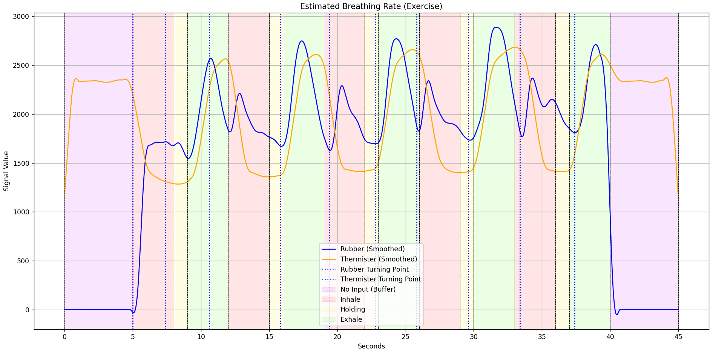
Fig 9. Post-exercise breathing cycle detection. The user is breathing with the 3-1-3 breathing technique to simulate quickened breathing.

The digital interface identifies peaks and troughs by detecting changes in the signal gradient, using a short debounce window to avoid false detections caused by local extrema. This approach ensures that only significant trends are considered in cycle detection. As observed in the data, the conductive rubber sensor often produces a secondary, smaller peak following the primary one, whereas the TMP61 signal more closely approximates a sinusoidal waveform. The final breath cycle count is determined by comparing the cycle detections from both sensors. In cases where the two do not agree, the count from the TMP61 is prioritized due to its more consistent signal profile.

4.0 Performance Assessment
$MSE =\frac{1}{n}\sum_{i=1}^{n}{} {(Y_{i}-{\hat{Y}}_{i} )}^{2}$ [Eq. 1]

Equation 1 outlines the mean squared error calculation, where n is the number of observations in the dataset, $Y_{i}$ is the actual value of the observation, and ${\hat{Y}}_{i}$ is the predicted value of the ith observation. Using this equation, data across 100 samples of 5 normal breath cycles following the 4-2-4 technique outlined earlier found an MSE of 0.08, with several samples being read as 4 or 6 breath cycles (Figure ). The MSE was slightly higher for breathing post-exercise, with an MSE of 0.15. As the ground truths for breathing cycles after exercise are obtained by manual counting, the higher errors in sensor output might be attributed to human errors in ground truth definitions.
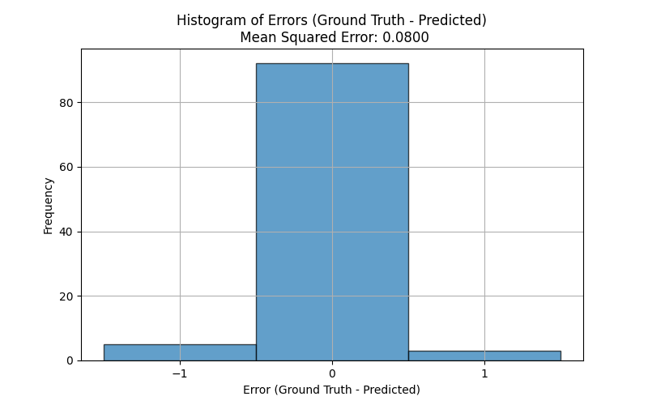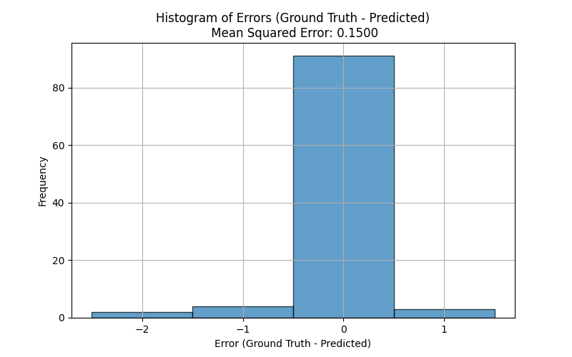
Fig 10. Histogram of Error between ground truth and predicted value for resting (left) and after exercise (right)

$f(x) = \frac{1}{1 + e^{-k(x-x_{0})}}$ [Eq. 2]

The just-noticeable difference (JND), defined in Equation 2, was determined by evaluating the complete sensing system—including both hardware and software—without modification. The system outputs integer breath cycle counts, based on threshold crossings by both sensors that signify completed inhalation and exhalation phases.

JND testing was performed using a controlled, single-cycle breathing pattern. The baseline pattern, the 4-2-4 technique (4 seconds inhale, 2 seconds hold, 4 seconds exhale), was incrementally reduced by 0.2 seconds per phase. This resulted in the first step being 3.9 seconds inhale, 1.9 second hold, and 3.9 second exhale—a total reduction of 0.6 seconds per step for the first 10 steps. Once the hold phase reached 0, further reductions continued at 0.4 seconds per step. This decrement was selected as the smallest time interval that a person can reliably perform, and it was applied uniformly across all phases to maintain balance in the breathing pattern. Each condition was tested in 10 repeated trials.

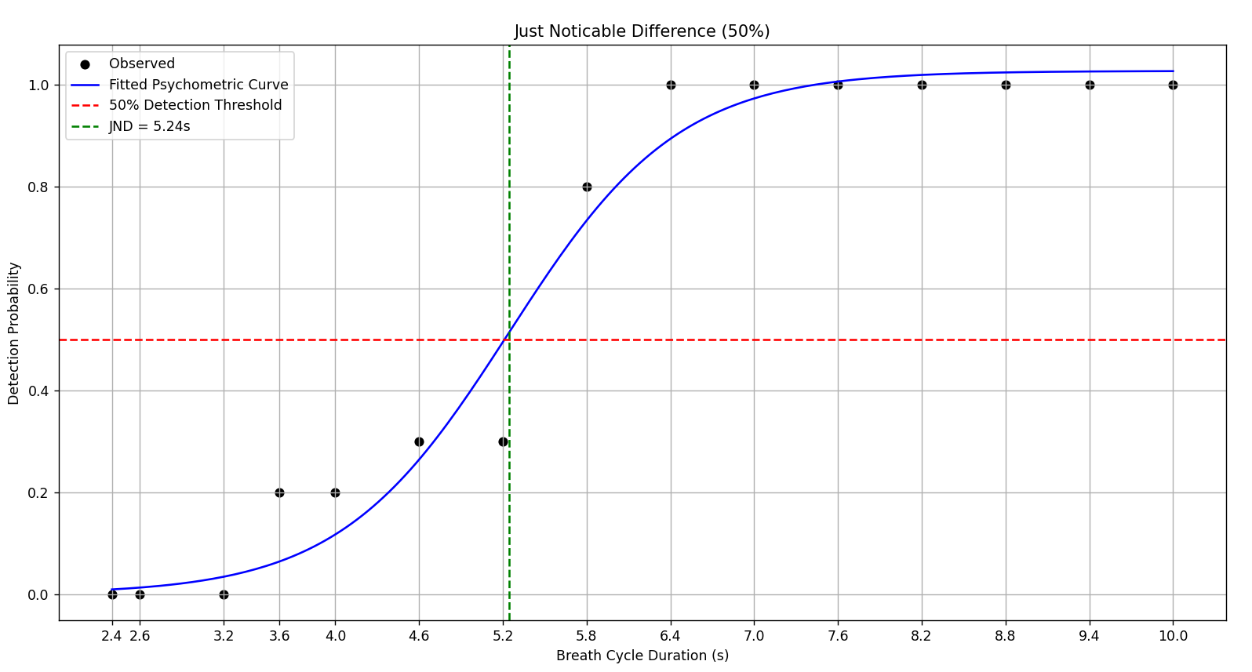
Fig 11. JND psychometric curve

As shown in Figure 11, the system's just-noticeable difference (JND) corresponds to approximately 5.24 breaths per minute, which roughly aligns with a 2.4-0.4-2.4 second breathing pattern. The reduced probability of cycle detection at this rate is due to insufficient chest expansion and limited airflow, resulting in the TMP61 receiving less thermal input. Consequently, the signal amplitudes fall below the thresholds required for reliable peak and trough separation, even after all digital signal processing techniques are applied. As a result, the system fails to register a full cycle, outputting a count of zero.
Though incorporating a third sensor could potentially reduce detection uncertainty by enabling the use of joint probability methods across multiple signals, this would significantly increase system complexity. The additional sensor would not only require more sophisticated circuitry and software but could also affect user comfort as they would need to have 3 bodily metrics being measured. Furthermore, adding a third sensor may introduce challenges such as signal crosstalk and non-negligible switching delays in hardware or software multiplexing unless the sensors are carefully isolated.

5.0 Conclusion
The end product of the breath-rate sensing module proves to be a cost-effective, accurate, and reliable biosensing solution ready for integration into wearable systems. Through iterative testing and calibration across both hardware and software components, the system successfully captures and calculates breath cycles using real-time sensor data from a TMP61 and a conductive rubber stretch sensor through an STM32 microcontroller, which is then processed digitally with a Python-based interface.

Though the majority of noise was removed through the use of low-pass filters in the circuitry, a moving average window was used to further reduce noise and preserve key features digitally. The system demonstrated strong performance under both normal and post-exercise breathing conditions in identifying breath cycles, though post-exercise had a slightly lower accuracy. However, these discrepancies were attributed to human error due to fatigue from repeated testing rather than circuit limitations.

Future work can focus on improving system responsiveness under varying breathing patterns and exploring multi-sensor fusion to further increase detection accuracy—though trade-offs in circuit complexity and user comfort must be carefully considered. Nevertheless, the breath-rate module meets its current design goals and is well-suited for further development in real-time wearable health monitoring applications.

6.0 References
[1] “FREE Online Breathing Timer,” mindfuldevmag.com. https://mindfuldevmag.com/breathing-timer/

7.0 Appendix
The GitHub repository for this project can be found at: Group B1 repository

